For partial training of the set: randomly pick the arbitrary size of the samples you want:

1. Run the code ImageGenerationScript.m from the following path C:\Projects\caffe\examples\mnist\PartialSet
2. So now we have 4 folder created (C:\Projects\caffe\examples\mnist\PartialSet). Testing and training are the full data sets while the partial are 1000 per digit for training and 400 per digit for testing

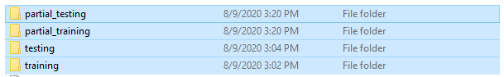

1. Download JPG-PNG-to-MNIST-NN-Format-master (<https://github.com/contactprabhatsingh/JPG-PNG-to-MNIST-NN-Format>)
2. Copy the folders training and testing with their subfolders to the (C:\Python27) path and rename them to training-images and test-images respectively.
3. Copy resize-script.sh from JPG-PNG-to-MNIST-NN-Format-master to C:\Python27
4. Open git bash and run sh resize-script.sh (cd C:/Python27)
5. Line 25 in must be changed to: label = int(filename.split('\\')[1])
6. Open cmd
7. Type c:/python27
8. python convert-images-to-mnist-format.py

The following folders will be created

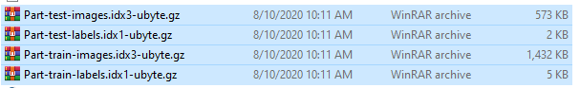

1. For some reason, the convert-images-to-mnist-format.py code skips the first folder, so what I did is that I added an empty folder called 0, and kept it empty, while I renamed the zero folder to 00.
2. Then open git bash and go to the directory where the .sh file exists (cd C:/Projects/caffe/examples/mnist ) and then type: sh create_mnist.sh. At this stage both mnist_train_partial_lmdb and mnist_test_partial_lmdb are created in C:\Projects\caffe\examples\mnist
3. Then run the model sh train_lenet.sh